 | SIMATS ENGINEERING  Department of Computer Science and Engineering  CSA15 Cloud Computing and Big Data Analytics  CO2 AT3 - Capstone Cloud Infrastructure Case Analysis and Defense  Editable student template for application-based cloud virtualization and SDDC/cloud operations defense
Assessment Metadata
Course Code | CSA15
Course Title | Cloud Computing and Big Data Analytics
Assessment | CO2 AT3 - Capstone Cloud Infrastructure Case Analysis and Defense
Submission Type | Individual digital case analysis and infrastructure defense based on the same capstone title used in CO1, CO2 AT1 and CO2 AT2
Faculty | Dr C. Rajesh Babu
Employee ID | SSETSCS415
Submission Mode | Completed DOCX template and GitHub repository link through Google Classroom
How This Template Works
- Use the same capstone title used in CO1, CO2 AT1 and CO2 AT2.
- Do not recalculate all VM sizing or repeat all configuration screenshots. Summarize the final AT1/AT2 evidence and use it for design defense.
- Answer all five questions with application-oriented reasoning connected to the capstone product.
- Include sustainable cloud operation decisions wherever relevant: right-sized resources, log retention, storage lifecycle, scheduled shutdown, API-call reduction and VM/container/serverless comparison.
- Paste the final topology diagram in the given response area. The sample diagram is only a structure; redraw it for the student's own product.
- Upload this completed document and supporting evidence to GitHub, then submit the repository link through Google Classroom.
Assessment Focus
AT1 answered what VM is required. AT2 showed configuration or simulation evidence. AT3 asks whether the student can defend the complete infrastructure design under application, security, operations and failure conditions.
Student and Capstone Details
Student Name | K DHEEPAK
Register Number | 192411108
Class / Slot | Slot B
Capstone Title | NewsTrust Cloud Misinformation Monitor Using NLP Credibility Scoring
CO1 Evidence Link
CO2 AT1 VM Recommendation | vCPU: 2 RAM: 4 GB Storage: 50 GB VM Class: General Purpose (e.g., t3.medium / B2s) — replace with your actual CO2 AT1 figures
CO2 AT2 Evidence Link
GitHub Repository Link | https://github.com/DHEEPAKKAMALAKANNAN/CSA1517-CLOUD-COMPUTING
Submission Date | 13-08-2026
Evidence Carry-Forward Summary
Evidence Source | Student Entry | How It Supports AT3 Defense
CO1 concept map / presentation | [Insert your CO1 concept map/presentation link] | Establishes NewsTrust's core NLP credibility-scoring concept and confirms the same product carried through AT1-AT3.
CO2 AT1 sizing workbook | [Insert AT1 sizing workbook link] | Provides the baseline vCPU/RAM/storage sizing used to justify the VM class selected for the NLP scoring service.
VM calibration sheet | [Insert VM calibration sheet link] | Confirms measured CPU/RAM utilization under scoring load, validating the right-sized VM choice.
CO2 AT2 practical evidence | [Insert AT2 screenshots/evidence link] | Demonstrates a working VM/container deployment of the credibility-scoring pipeline referenced in this defense.
Capstone architecture decision | Microservice architecture with a containerized NLP scoring engine | Forms the basis of the topology and integration design defended in Q3.
Q1: Virtualization Value and Capstone Cloud Deployment Summary
Explain your capstone product, expected workload, cloud need and deployment context. Analyze how virtualization improves cost efficiency, resource utilization, workload isolation, infrastructure flexibility and cloud deployment readiness for your product.
Design Point | Student Response
Capstone product and users | NewsTrust is a cloud-hosted misinformation monitoring platform that scans trending news articles and social posts, scores them for credibility using an NLP classifier, and presents results to journalists, fact-checking teams and the public through a web dashboard.
Expected workload | Bursty, read-heavy workload with periodic spikes during breaking-news events; continuous background NLP inference on newly ingested articles (roughly 500-2,000 articles/day, spiking sharply during major news cycles).
Cloud need | Elastic compute for the NLP scoring pipeline, an always-available API/database, and low-latency content delivery for the public dashboard.
Virtualization value | Virtualization lets the NLP model, API layer and database run as isolated VMs/containers on shared hardware, so each component can be scaled, patched or restarted independently without affecting the others.
Cost and utilization benefit | Right-sizing the scoring VM avoids paying for idle CPU capacity outside peak news cycles; lightweight services (API, scheduler, notifications) are consolidated on fewer hosts through containers, improving utilization.
Isolation and flexibility benefit | Isolating the NLP scoring container from the public API protects the system if the model crashes or is retrained; new model versions are tested on a cloned VM before being promoted, without downtime.
Virtualization is central to NewsTrust because the platform combines a latency-sensitive public API with a compute-heavy NLP credibility-scoring engine, and virtual machines let each be sized and scaled on its own schedule. The scoring engine only needs full resources when a burst of articles arrives after breaking news, so its VM/container pool can scale up temporarily and back down afterward instead of over-provisioning the whole stack permanently. Virtualization also isolates experimental work - retraining or fine-tuning the credibility model - from the production API and database, so a failed training run cannot take down the live dashboard. Snapshots and VM images from CO2 AT1/AT2 let the team roll back to a known-good scoring service instantly if a new model version misbehaves, which matters for a misinformation product where downtime or bad scores carry real credibility consequences. Because virtualization abstracts the hardware, the same NewsTrust image deploys identically in development, staging and production, shortening the path from the CO1 concept to a defensible AT3 deployment. Overall, virtualization turns NewsTrust from a single monolithic script into a set of independently deployable, cost-controlled and fault-isolated services.

Q2: Rapid Provisioning, Testing and Virtual Machine Lifecycle Case
Using your CO2 AT1 VM recommendation and CO2 AT2 practical evidence, explain how virtual machines, VM images, templates, snapshots, clones or containers support rapid provisioning, testing, deployment, rollback and maintenance for your capstone product.
Lifecycle Element | AT1/AT2 Evidence Used | Capstone Use / Justification
VM image or base environment | Base Ubuntu VM image sized per CO2 AT1 (2 vCPU / 4 GB RAM) with Python and NLP libraries pre-installed | Used as the golden image for every new NLP scoring worker, so a fresh worker boots ready-to-score in minutes.
Template or repeatable setup | AT2 configuration checklist for installing FastAPI, model weights and DB drivers | Converted into a reusable VM template/Dockerfile so dev, staging and prod environments are provisioned identically.
Snapshot / rollback | Pre-deployment VM snapshot taken during AT2 testing | A snapshot is taken before every model or code update, so NewsTrust can roll back in minutes if a new scoring model misbehaves.
Clone / testing copy | Cloned VM used in AT2 to test scoring accuracy without touching production | New NLP model versions are validated on a cloned VM against a sample article set before promotion to production.
Container or VM decision | AT1 VM sizing compared against an AT2 container trial | The NLP scoring service runs in a container for fast horizontal scaling during news spikes, while the database stays on a persistent VM for stability.
Maintenance and update plan | AT2 patch/update log | Monthly OS patching and model retraining are scheduled during low-traffic windows, using clones to avoid downtime.
Using VM images, templates, snapshots and clones turns NewsTrust's deployment from a manual, error-prone process into a repeatable one. A golden VM image means every new scoring worker starts from the same tested baseline, removing the 'works on my machine' risk during rapid provisioning. Snapshots taken before each model or code deployment give an instant rollback path, which matters because a broken credibility-scoring update could mislabel real news as misinformation. Clones let new NLP model versions be tested against production-like data without risking the live dashboard, cutting the time between AT1 sizing and a defensible AT3 deployment. Because the scoring service is containerized, new workers start or stop within seconds to absorb traffic spikes, while the template keeps every worker configured identically, reducing both deployment delay and operational risk.

Q3: Final Cloud Deployment Topology and SOA/API Service Integration Case
Draw and explain the final deployment topology for your capstone product. Show frontend, backend/API, database, storage, authentication, notification, analytics and any VM/container/managed cloud service components. Explain how SOA/API-based integration connects these modules and supports modular cloud service design.
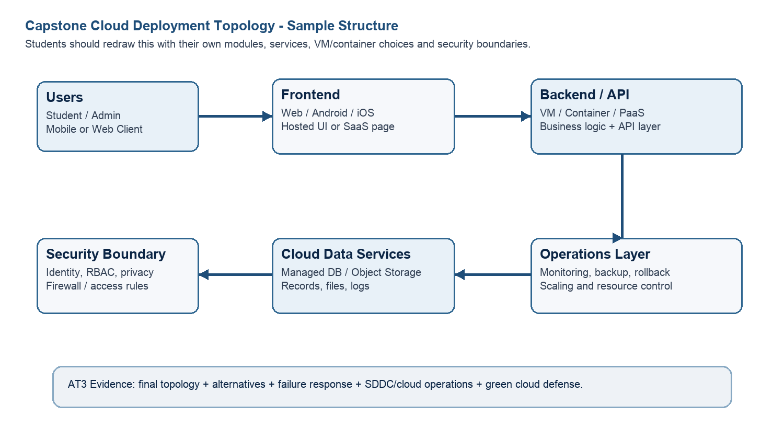
Architecture Component | Technology / Service | VM / Container / Managed Service / SaaS | Integration Method
Frontend | React.js dashboard (Next.js), served as a static site | Managed static hosting (CloudFront + S3 / Vercel) | Calls the backend REST API over HTTPS/JSON
Backend/API | FastAPI (Python) REST service | Containerized (Docker) on ECS Fargate / VM | Exposes REST/JSON endpoints; calls the NLP scoring service internally via REST
Database | PostgreSQL | Managed database service (Amazon RDS) | Backend connects via a secured DB driver over a private subnet
Storage | Object storage for raw article snapshots and model artifacts | Managed object storage (Amazon S3) | Backend and NLP service read/write via storage SDK/API
Authentication | OAuth2/JWT-based identity | Managed identity service (AWS Cognito / Auth0) | Frontend redirects to the auth service; API validates JWT on each request
Notification | Email/push alert service for misinformation trend alerts | Managed pub/sub + notification (Amazon SNS) | Backend publishes events; SNS fans out to email/app notifications
Analytics / AI module | NLP credibility-scoring engine (transformer-based classifier) + analytics dashboard | Containerized inference service, autoscaled | Backend calls the scoring service via an internal REST API; results are written back to the database
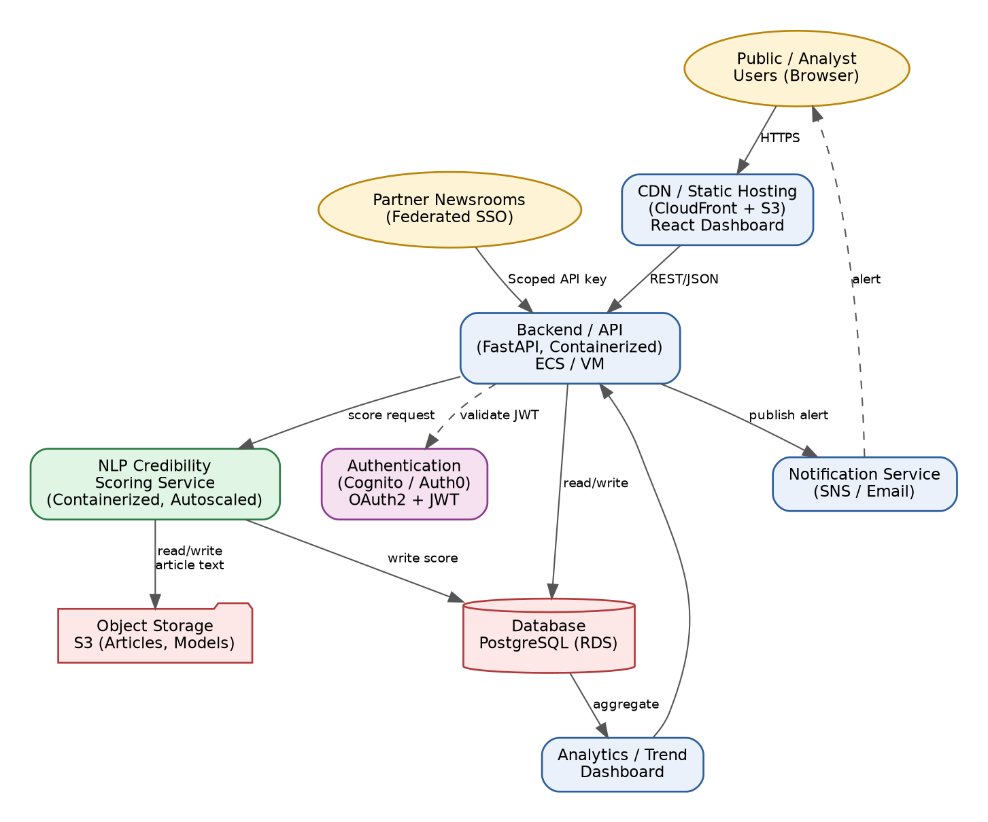

NewsTrust is built as a set of loosely coupled services that communicate only through well-defined REST/JSON APIs rather than sharing code or a database directly. The frontend never talks to the database or the NLP model directly - it always goes through the backend API, which acts as the single entry point and enforces authentication and rate limits. The backend, in turn, calls the NLP credibility-scoring service as its own internal API, so the scoring model can be upgraded, scaled, or replaced without changing the frontend or database layer. This SOA-style separation means each module can be deployed, scaled and rolled back independently: during a breaking-news traffic spike, only the scoring service and backend need to scale, while storage and notification stay untouched. It also makes the system easier to defend under failure, since a fault in one service, such as notifications, is isolated behind its API and does not cascade into the frontend or database.

Q4: Design Alternatives, Identity, Access and Federated Cloud Privacy Case
Compare at least two deployment alternatives for your capstone product, such as single VM, multi-tier VM, containerized deployment, managed backend, federated cloud or hybrid cloud model. Justify the selected design by analyzing identity management, role-based access control, federated access, data sharing, privacy protection and security risks.
Deployment Alternative | Advantages | Limitations / Risks | Identity and Privacy Impact
Single VM (all-in-one) | Simple to set up and cheap for a prototype; everything (API, DB, NLP model) runs on one VM | No isolation - a crash in the NLP scoring code can take down the API and database together; hard to scale only the scoring workload during a news spike | All roles and data share the same OS/user space, so a compromised component exposes everything on the VM
Multi-tier containerized deployment | Frontend, API, NLP scoring and database run as separate containers/VMs, so each layer scales and fails independently; matches AT1/AT2 evidence | More moving parts to monitor and secure; requires container orchestration and network segmentation | Each service can have its own least-privilege identity/role, keeping database credentials away from the public-facing frontend
Selected design: Multi-tier containerized + managed services | Combines the isolation of multi-tier design with reduced operational overhead by using managed services (RDS, Cognito) for the highest-risk components | Slightly higher cost than a single VM; depends on cloud-provider managed services | Sensitive user and article data stays behind RBAC-protected APIs and a managed, encrypted database, minimizing exposure
Security Area |  | Student Decision
User roles |  | Public reader, registered analyst/fact-checker, admin
Authentication method |  | OAuth2 with JWT access tokens issued by a managed identity provider (Cognito/Auth0)
Role-based access control |  | Admin manages sources and models; analysts can flag/review scored articles; public users have read-only access to published credibility scores
Federated access / partner access |  | Partner newsrooms authenticate via federated SSO (SAML/OAuth) and pull credibility scores through a scoped, read-only API key
Sensitive data handled |  | User account details, analyst review notes, and scraped article content/source metadata
Privacy protection decision |  | Personal account data is encrypted at rest and in transit; scraped content is stored with source attribution only; API keys are scoped to least privilege per partner
The multi-tier containerized design was selected over a single VM because NewsTrust handles sensitive account data, partner API access and public-facing misinformation scoring at the same time, and these need different trust levels. Putting the database behind a managed, RBAC-protected service keeps analyst and admin credentials away from the public API surface, so a bug in the public dashboard cannot leak database access. Federated access for partner newsrooms is only clean in the multi-tier design, since it can be exposed through a separate, scoped API layer instead of direct database access. Role-based access control lets the system distinguish between a public reader, an analyst and an admin without duplicating logic across services, since every service checks the same JWT claims. This design protects privacy better than a single VM because a compromise of the frontend or NLP container does not automatically expose database credentials or partner keys, which sit in a separate, more tightly controlled tier.

Q5: Software-Defined Datacenter and Cloud Operations Defense Case
Analyze how your infrastructure will respond to operational and failure scenarios such as VM failure, database growth, traffic spike, credential leakage, service outage, resource contention or cost increase. Explain how SDDC concepts and cloud operations practices such as automated provisioning, software-defined networking, software-defined storage, monitoring, logging, backup, rollback, scaling, resource control and maintenance improve the final infrastructure design. Include Green Computing decisions such as resource right-sizing, storage lifecycle control, log retention, API-call reduction, scheduled shutdown, VM/container/serverless comparison and carbon/energy proxy indicators where relevant.
Operational / Failure Scenario | Expected Impact | SDDC / Cloud Operations Response | Evidence or Control
VM failure | Scoring pipeline stalls; new articles are not scored until the service recovers | Auto-scaling group / orchestrator (ECS/Kubernetes) automatically replaces the failed instance from the AT1/AT2 base image | Health-check + auto-restart policy; VM image from CO2 AT1
Database growth | Slower queries and rising storage cost as scored articles accumulate | Software-defined storage with a lifecycle policy archives old article data to cold storage; DB read replicas added if needed | Storage lifecycle rule + monitoring dashboard on DB size
Traffic spike | API latency increases during a breaking-news surge in dashboard visits | Horizontal auto-scaling of API/frontend containers behind a load balancer | Auto-scaling policy + CDN cache-hit metrics
Credential leakage | Unauthorized access to admin functions or the partner API | Immediate key/secret rotation, revoke affected tokens, enforce short-lived JWTs | Secrets-manager rotation log, RBAC audit trail
Service outage | Dashboard or scoring API becomes unreachable | Multi-AZ deployment with automated failover to a standby instance/region | Uptime monitoring + failover runbook
Resource contention | NLP scoring jobs slow down the API during simultaneous peak load | Resource quotas/limits separate the scoring container pool from the API pool so one cannot starve the other | Container resource limits, monitoring alerts
Cost increase | Cloud bill rises due to over-provisioned or idle scoring workers | Scheduled shutdown of idle scoring workers overnight; right-sizing review against the CO2 AT1 baseline | Cost/usage dashboard, scheduled shutdown policy
Operational Readiness Area |  | Student Plan
Automated provisioning |  | New scoring workers launch from the CO2 AT1/AT2 base image via an auto-scaling group, so capacity matches article-ingestion volume without manual VM creation.
Software-defined networking |  | Services sit in separate subnets (public frontend, private API/NLP tier, private DB tier) connected through security groups, so the database is never directly reachable from the internet.
Software-defined storage |  | Article snapshots and model artifacts use tiered object storage with lifecycle rules that move old data to cheaper cold storage automatically.
Monitoring and logging |  | Centralized logging and metrics (CPU, latency, scoring-queue length) with alerts on abnormal spikes or failed scoring jobs.
Backup and rollback |  | Nightly database backups plus pre-deployment VM/container snapshots, so a bad model or code update can be rolled back within minutes.
Scaling and elasticity |  | Scoring and API containers scale horizontally based on queue length/request rate; scale-in during low-traffic periods keeps cost proportional to demand.
Resource control and maintenance |  | Resource quotas per service, scheduled OS/library patching windows, and periodic review of VM sizing against actual AT1/AT2 usage data.
Green Computing and sustainability control |  | Idle scoring workers shut down automatically outside peak news hours, and VM sizes are reviewed against real usage instead of over-provisioning by default.
Green Cloud Decision |  | Student Justification
VM right-sizing from CO2 AT1 |  | The scoring VM/container is sized to the CO2 AT1 baseline rather than a larger default, avoiding wasted compute during normal (non-spike) traffic.
VM vs container vs serverless choice |  | The NLP scoring workload uses containers (fast to scale up/down) instead of always-on VMs; lightweight tasks like notification dispatch use serverless functions that consume nothing when idle.
Scheduled shutdown / idle-resource control |  | Non-production (staging/test) environments are shut down outside working hours, and scoring worker pools scale to zero overnight when article volume is low.
Log and file retention policy |  | Detailed logs are kept for 30 days and then summarized/archived, instead of being stored indefinitely, reducing storage growth.
Storage lifecycle and backup cleanup |  | Old scraped-article snapshots move to cold storage after 90 days and expired backups are automatically deleted per a lifecycle policy.
API-call or polling reduction |  | The dashboard uses event-driven/webhook updates instead of constantly polling the API for new scores, cutting unnecessary compute cycles.
Carbon/energy proxy indicator to track |  | Total vCPU-hours consumed per day by the scoring service, tracked against article volume, as a proxy for energy use and a target for right-sizing reviews.
The NewsTrust infrastructure, as designed and defended here, is ready for a pilot deployment: the multi-tier containerized architecture, RBAC-protected identity model and SDDC practices (auto-scaling, monitoring, backup/rollback) cover the reliability and security needs of a limited pilot with real newsroom partners. It is not yet ready for full production, since that would require load-testing the NLP scoring service at a larger article volume, a formal incident-response runbook for credential leakage, and completion of the Green Computing carbon-proxy tracking dashboard. Before scaling beyond pilot, the team should validate multi-AZ failover under real failure injection and confirm the cost/usage dashboard accurately reflects right-sizing decisions.

CO2 Reflection and Individual Defense
This section must be individually written. It should show what the student understands from the complete CO2 chain: infrastructure sizing, practical configuration evidence and final operations defense.
Reflection Prompt | Student Response
What is the strongest infrastructure decision in your capstone design? | Separating the NLP credibility-scoring service into its own containerized, independently scalable tier is the strongest decision, because it lets the system absorb breaking-news traffic spikes without over-provisioning the whole stack.
Which CO2 concept became clearer after AT1, AT2 and AT3? | How VM right-sizing from AT1 directly feeds into the Green Computing and cost-control decisions in AT3 became much clearer after working through AT1, AT2 and AT3 together.
Which risk is most serious for your capstone: failure, cost, privacy, scaling or sustainability? | Scaling risk is the most serious for NewsTrust, since a real misinformation event can cause a sudden, hard-to-predict surge in both article volume and public dashboard traffic at the same time.
What evidence would you show during viva to defend your infrastructure design? | I would show the CO2 AT1 VM sizing workbook, the AT2 deployment/snapshot evidence, the topology diagram from Q3, and the monitoring/cost dashboard supporting the Green Computing decisions in Q5.
What will you improve before final capstone deployment? | Before final deployment I would add automated load testing for the scoring service and complete the carbon/energy proxy tracking so the Green Computing claims in this defense are backed by real measured data.

Student-Facing Assessment Criteria
Criteria | Descriptor
Capstone continuity | The answer uses the same capstone title and connects CO1, CO2 AT1 and CO2 AT2 evidence.
Virtualization and lifecycle reasoning | VM, image, snapshot, clone, container or managed-service decisions are technically justified.
Topology and integration clarity | Architecture diagram and SOA/API explanation show clear module interaction.
Identity, access and privacy | Roles, authentication, RBAC, federated access, sensitive data and privacy decisions are defended.
SDDC/cloud operations | Failure response, monitoring, logging, scaling, backup, rollback and resource control are addressed.
Green Computing defense | Right-sizing, retention, API efficiency, idle-resource control and sustainable cloud choices are explained.
Submission quality | GitHub, template completion, evidence references and individual reflection are complete.
GitHub and Google Classroom Submission
Repository Item | Expected Content
README.md | Capstone title, student details, final VM recommendation, deployment topology summary and AT3 evidence index.
Completed AT3 document | This completed editable DOCX or exported PDF if instructed.
Diagram image | Final topology diagram if created separately.
Evidence references | Links or screenshots from CO1, CO2 AT1 and CO2 AT2 as needed.
Green Computing note | Short README section explaining sustainable cloud choices and resource-control decisions.
Google Classroom | Submit the GitHub repository link through GCR.
Student Assurance
I confirm that this case analysis, design reasoning, topology diagram and final defense statement were prepared individually by me for the stated capstone title. I have not uploaded passwords, tokens, private keys or sensitive account information.
Student Name | K DHEEPAK
Register Number | 192411108
Signature | K DHEEPAK
Date | 13-08-2026

Faculty Verification
Faculty Name | Dr C. Rajesh Babu
Employee ID | SSETSCS415
Constructive Feedback / Remarks
Strength Observed
Improvement Suggested
Signature / Date

